1. How to boost your immune system
Read and put down the unknown words

https://www.vogue.com/article/how-to-boost-immune-system

1.1 Word formation exercise
https://www.english-grammar.at/online_exercises/word-formation/wf041-sentences.htm

1.2 Write 15 sentences using 3 unknown words in each sentence

1.3 Paint a mind map using active vocab from the article

2. Exercise, meditation, sleep and stress management
https://edition.cnn.com/2020/03/26/health/immunity-exercise-sleep-meditation-stress-coronavirus-drayer-wellness/index.htm
2.2 put down the unknown words of the 50 % of the article
2.3Write 10 sentences using 3 unknown words in each sentence

2.4 put down the rest of the words
2.5 Write 10 sentences using 3 unknown words in each sentence

2.6
complete with infinitive, bare infinitive or gerund
(Intermediate) https://www.englishpage.com/gerunds/gerunds_infinitives_14.htm

(Intermediate) https://www.englishpage.com/gerunds/gerunds_infinitives_19.htm

2.7 Paint a mind map using active vocab from the article

3. Watch a video and put down the unknown words
How to make healthy eating unbelievably easy | Luke Durward | TEDxYorkU
https://youtu.be/Q4yUlJV31Rk

3.1 complete with infinitive, bare infinitive or gerund
(Upper Intermediate) https://school-english.de/english/uebungen/gerundium/remember.htm

(Advanced) http://baladre.info/english/sedaviwebfront/geruninfinitive7.htm

4. Exercise 4
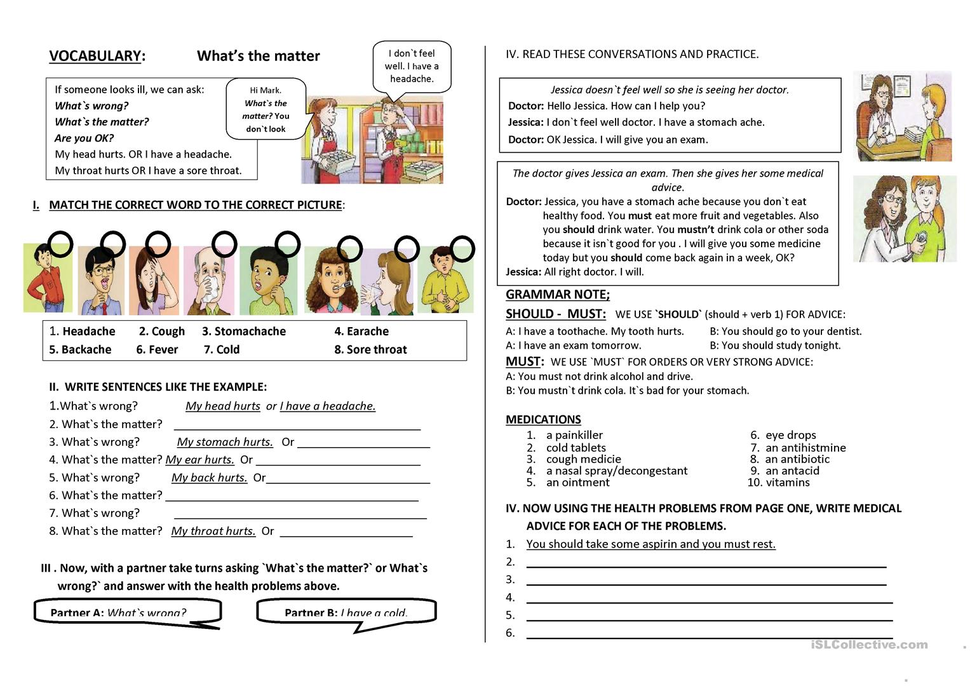

5. Exercise 5

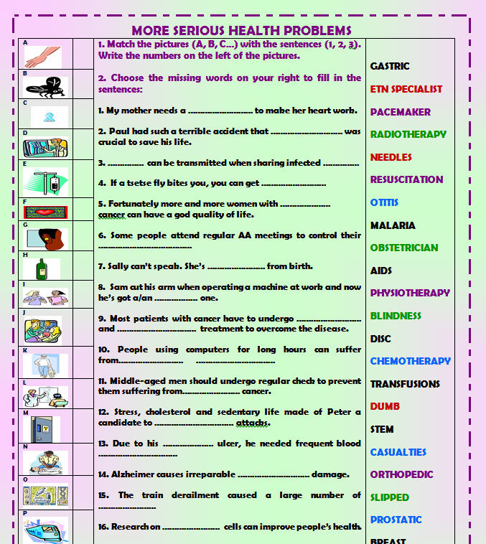

6. Exercise 6
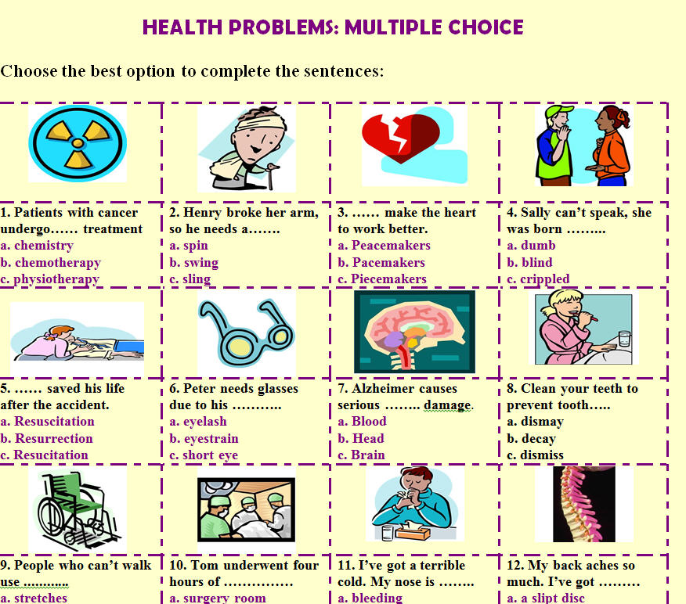

7.Essay topics
https://www.ieltsbuddy.com/ielts-essay.html
In this introductory lesson you will find some guidance on how you should write an IELTS essay
Topics
1 How to fight infection by turning back your immune system's clock.
2 Today more people are overweight than ever before. What in your opinion are the primary causes of this?
3 Health education is an essential aspect of community health. Do you agree or disagree?

