1. Please, watch this video

How Women Think (Stand Up Comedy)

https://www.youtube.com/watch?v=Bu-MBbhy5qE

2. Put down the unknown words

3. Useful vocab
to ask someone out
to chat (somebody) up
to talk to somebody in the hope of starting a romantic or sexual relationship
to flirt (with somebody)
to behave playfully towards another person who you are – or pretend to be – attracted to romantically or sexually
steady relationship
a flirt
a person who likes to flirt
a blind date
a meeting (arranged by a third party) with a person you might be interested in romantically but who you have never met before
to have a crush on someone
to fall in love with someone
lonely hearts
small ads (in newspapers, magazines or on the internet) which give a short description of a person you would like to date. To save space, some of these abbreviations are used:
WLTM – would like to meet
GSOH – good sense of humour
LTR – long-term relationship

Loved up – being in a relationship
to be smitten with somebody
to be deeply affected by your love for somebody
to fall for somebody
to fall in love with somebody
it was love at first sight
two people fell in love with each other as soon as they met
to take the plunge
to get engaged/married
I can hear wedding bells
I suspect that they are going to get married soon

terms of endearment
names people in love give each other or call each other:
To see eye-to-eye on most things so we rarely
• to fall head over heels in love: to start to love someone a lot
• to get on well with: to understand someone and enjoy similar interests
• to get to know: to begin to know someone
• to go back years: to have known someone for a long time
• to have a lot in common: to share similar interests

Break up – finishing a relationship
they are having a domestic (informal)
they are having an argument
they have blazing rows
they have very serious, often noisy arguments
(s)he is playing away from home
(s)he is having an affair
to break up with somebody
to finish a relationship with somebody
to split up
to break up
to dump somebody
to finish a relationship with somebody without much thought for the other person
to have ups and downs: to have good and bad time

Use the expressions below to fill out the gaps
engaged, get married,playing the field ,flirt, crush, steady, find the one , casual ,flirting , break up, have a crush on someone, engagement, significant other,boyfriend, girlfriend, Butterflies in your stomach, divorce

When they are dating, people are often either ‘_______’ or interested in a ______relationship. A ‘casual’ dater, someone ‘__________, is someone who isn’t looking for a serious relationship, while a ‘steady’ dater is looking to possibly settle down with the right person soon.
Maybe you haven’t had the opportunity to ask the person you like out on a date yet, or perhaps you only __________’. A ‘_____ is when you really like someone but you haven’t told them yet. Perhaps you might start ‘_______’ with them. If you ‘____’ with someone, it means you are trying to playfully impress them.
Once people have started a serious relationship, they often say they have ‘________’, referring to their ‘_________’ or ‘________’, the person they want to be with forever. Before they ‘_______ and make their relationship legally binding, some people enter into an ‘_________’. When two people are ‘________’, it means they have made an agreement to get married. There is often an engagement ring representing this promise.
However, sometime love stories come to end. Perhaps you and your ‘___________ (the person you are with: boyfriend, girlfriend, husband or wife) no longer feel the same way about each other, and you no longer have ‘____________ (that nervous feeling in your belly when you’re with someone in the beginning). It might be time to ‘_______ with the other person.
This means to end the relationship and go your separate ways. If you are married, this break up
would be called a ‘_______’. You would need to officially document the separation to end your marriage.
Well, let’s not leave on a sad note here! There are other types of relationships like your ‘best friend’. This is a friend that you are very close to and share many aspects of your life with. Some say relationships come and go, but friendships remain.

Understanding Your Love Language. Jeff Allen https://www.youtube.com/watch?v=bXpr7SCq4A4&t=186s

Being married VS. Being Single | Drew Barth | Dry Bar Comedy
https://www.youtube.com/watch?v=ap9Zu_HXz-M
- закінчуються речі
- (idiomatic) having completely exhausted one's supply of (a commodity закінчились ідеї
- спадати на думку
- відкрутити
- зазначити наголосити на чомусь
- привабливий , цікавий
- є шанси,що
- якщо щиро,то /чесно кажучи

Use the expressions from the above to fill out the gaps

- Some economists have ________ that low inflation is not necessarily a good thing.
- If you drive a car all your life, the _______ that you'll have an accident at some point.
- She answered all our questions _________.
- The idea of living in Paris is very _________.
- We’re _________oranges, would you like anapple?
- He was always very keen to _________my mistakes.

- What was the first thing that _____your _______ when you won the prize?
- The city offers an _________ combination of sporting and cultural events.
- Pills are stored in containers with tops that are difficult for children to _________.
- The murder was obviously well planned, as the inspector had _________
- Robyn _________ a jar of moisturiser and smoothed it over her face and neck.
- It never ________ (= I neverthought) that she might be married.
- I can't _________ the lid.
- She was sick yesterday, so the _________she won’t be in today.
- Nicholas _________ admitted that the report was a pack of lies
- I’m sorry, I’m _________ coffee.
- It creates an atmosphere which visitors find so _________
- Many hospitals are _________money.
- _________, I think the Internet is overrated.

Research: Women Score Higher Than Men in Most Leadership Skills
Alex and Laila/Getty Images
For the first time in history, a major political party in the United States has several women who have declared their candidacy to be their party’s presidential nominee. But TV pundits have been questioning whether, despite the progress indicated by the huge influx of women elected into Congress last fall, the U.S. is ever going to elect a woman to the country’s highest leadership position.
This is baffling to us, especially in light of what we see in our corporate research. In two articles from 2012 (here and here) we discussed findings from our analysis of 360-degree reviews that women in leadership positions were perceived as being every bit as effective as men. In fact, while the differences were not huge, women scored at a statistically significantly higher level than men on the vast majority of leadership competencies we measured.
We recently updated that research, again looking at our database of 360-degree reviews in which we ask individuals to rate each leaders’ effectiveness overall and to judge how strong they are on specific competencies, and had similar findings: that women in leadership positions are perceived just as — if not more — competent as their male counterparts.
Still, the disturbing fact is that the percentage of women in senior leadership roles in businesses has remained relatively steady since we conducted our original research. Only 4.9% of Fortune 500 CEOs and 2% of S&P 500 CEOs are women. And those numbers are declining globally.
There are of course many factors that contribute to this dearth of women at senior levels. For centuries, there have been broad, cultural biases against women and stereotypes die slowly. People have long believed that many women elect not to aspire to the highest ranks of the organization and take themselves out of the running (though recent research disputes that). Lots of research has shown that unconscious bias places a significant role in hiring and promotion decisions, which also contributes to the lower number of women in key positions.
Our current data presents even more compelling evidence that this bias is incorrect and unwarranted. Women are perceived by their managers — particularly their male managers — to be slightly more effective than men at every hierarchical level and in virtually every functional area of the organization. That includes the traditional male bastions of IT, operations, and legal.
As you can see in the chart below, women were rated as excelling in taking initiative, acting with resilience, practicing self-development, driving for results, and displaying high integrity and honesty. In fact, they were thought to be more effective in 84% of the competencies that we most frequently measure.
According to our updated data, men were rated as being better on two capabilities —”develops strategic perspective” and “technical or professional expertise,” which were the same capabilities where they earned higher ratings in our original research as well.

Women Are Rated Better Than Men on Key Leadership Capabilities
According to an analysis of thousands of 360-degree reviews, women outscored men on 17 of the 19 capabilities that differentiate excellent leaders from average or poor ones.
Capability | Women’s percentile | Men’s percentile
Takes initiative | 55.6 | 48.2
Resilience | 54.7 | 49.3
Practices self-development | 54.8 | 49.6
Drives for results | 53.9 | 48.8
Displays high integrity and honesty | 54.0 | 49.1
Develops others | 54.1 | 49.8
Inspires and motivates others | 53.9 | 49.7
Bold leadership | 53.2 | 49.8
Builds relationships | 53.2 | 49.9
Champions change | 53.1 | 49.8
Establishes stretch goals | 52.6 | 49.7
Collaboration and teamwork | 52.6 | 50.2
Connects to the outside world | 51.6 | 50.3
Communicates powerfully and prolifically | 51.8 | 50.7
Solves problems and analyzes issues | 51.5 | 50.4
Leadership speed | 51.5 | 50.5
Innovates | 51.4 | 51
Technical or professional expertise | 50.1 | 51.1
Develops strategic perspective | 50.1 | 51.4
Note: The t-values of all data are statistically significant.
Source: Zenger Folkman 2019 |  | © HBR
Find this and other HBR graphics in our Visual Library
Interestingly, our data shows that when women are asked to assess themselves, they are not as generous in their ratings. In the last few years we created a self-assessment that measures, among other things, confidence. We’ve been collecting data since 2016 (from 3,876 men and 4,779 women so far) on levels of confidence leaders have in themselves over their careers and we saw some interesting trends.
When we compare confidence ratings for men and women, we see a large difference in those under 25. It’s highly probable that those women are far more competent than they think they are, while the male leaders are overconfident and assuming they are more competent than they are. At age 40, the confidence ratings merge. As people age their confidence generally increases; surprisingly, over the age of 60 we see male confidence decline, while female confidence increases. According to our data, men gain just 8.5 percentile points in confidence from age 25 to their 60+ years. Women, on the other hand, gain 29 percentile points. One note: This is what we see in our data though we recognize that there are studies that come to different conclusions on whether women truly lack confidence at early stages in their career.
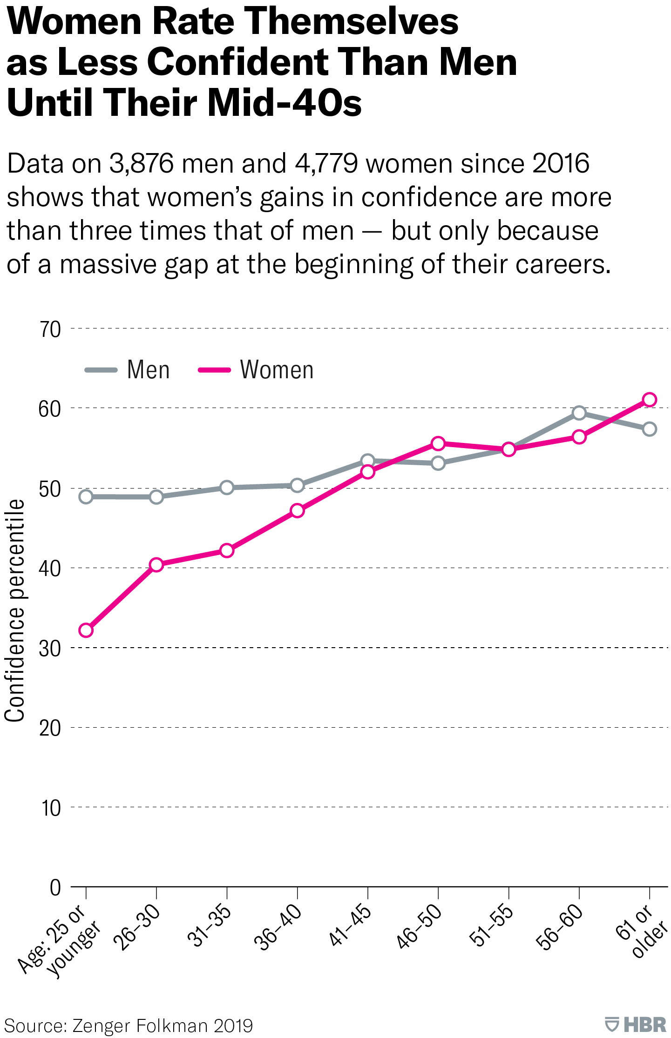
Find this and other HBR graphics in our
Visual Library
These findings dovetail with other research that shows women are less likely to apply for jobs unless they are confident they meet most of the listed qualifications. A man and woman with identical credentials, who both lack experience for a higher level position, come to different conclusions about being prepared for the promotion. The man is more inclined to assume that he can learn what he’s missing, while in the new job. He says to himself, “I am close enough.” The woman is inclined to be more wary, and less willing to step up in that circumstance.
It’s possible that these lower levels of confidence at younger ages could motivate women to take more initiative, be more resilient, and to be more receptive to feedback from others, which in turn makes them more effective leaders in the long run.
We see a similar trend in women’s perceptions of their overall leadership effectiveness, with their rating rising as they get older. This data is from a study that includes 40,184 men and 22,600 women and measures the overall effectiveness rating of males and females on 49 unique behaviors that predict a leaders effectiveness. Again, women at younger ages rate themselves significantly lower than men but their ratings climb — and eventually supersede those of men — as they get older.
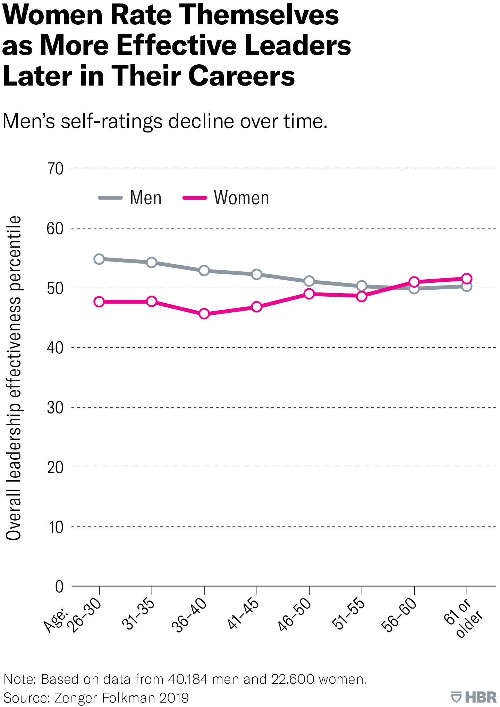
Find this and other HBR graphics in our
Visual Library
This data continues to reinforce our observations from our previous research — women make highly competent leaders, according to those who work most closely with them — and what’s holding them back is not lack of capability but a dearth of opportunity. When given those opportunities, women are just as likely to succeed in higher level positions as men.
Keep in mind that our data is mostly perceptions of current and past behavior and performance. That’s different than a promotional decision that involves movement to a higher position and involves taking a bigger risk. If 96 out of 100 people currently serving in comparable positions are male, and you are making the decision about who to promote, and you have a highly qualified female and a highly qualified male, what are you inclined to do? It may seem safer to choose the man.
Leaders need to take a hard look at what gets in the way of promoting women in their organizations. Clearly, the unconscious bias that women don’t belong in senior level positions plays a big role. It’s imperative that organizations change the way they make hiring and promotion decisions and ensure that eligible women are given serious consideration. Those making those decisions need to pause and ask, “Are we succumbing to unconscious bias? Are we automatically giving the nod to a man when there’s an equally competent woman?” And, as our data on confidence shows, there’s a need for organizations to give more encouragement to women. Leaders can assure them of their competence and encourage them to seek promotions earlier in their careers.

Speaking
You will have to record an audio ( not more than 5 min )
Do you agree with the fact that women and man think differently, especially when it comes to arguments, the way women and men behave while having a domestic

Grammar
Use the words in brackets as participles in the gaps.
Show example

Do you need help?
Participles, Participle constructions
Початок форми
- a car (break)
- the pizza (forget)
- the girl next door (live)
- the father (work)
- an story (interest)
- the computer (repair)
- the students (talk)
- fans (excite)
- a boy (wait)
- I saw him . (go)
Кінець форми
- He saw his friend (go) out with Sue.
- The bus crashed into the blue car (drive) down the hill.
- Peter hurt his leg (do) karate.
- The umbrella (find) at the bus stop belongs to John Smith.
- The people (dance) in the street are all very friendly.
- I heard my mother (talk) on the phone.
- My uncle always has his car (wash).
- We stood (wait) for the taxi.
- (look) down from the tower we saw many people walking in the streets.
- The people drove off in a (steal) car

Task No. 2427
Put in something, someone, somewhere or anything, anyone, anywhere into the gaps.
Show example

Do you need help?
something, anything and other compounds
Початок форми
- I've got in my eye.
- There is at the door.
- We haven't heard about Peter. Is he ill?
- Do you live near Mandy?
- wants to see you.
- Has seen my bag?
- My teacher asked me .
- Can I have to drink?
- Don't worry. can tell you where the post-office in this town is.
- I don't know about it.
Кінець форми

Task No. 2435
few or little? – Choose the correct answer.

Do you need help?
a little, a few
Початок форми
- This president had power.
- She spoke English. It was nearly impossible to understand her.
- They got complaints.
- I'm sorry, but I have time to waste.
- He is lucky. He has problems.
- They have interest in politics.
- There's very communication between them.
- children understood the difference.
- We had hope that his sister would survive.
- Very students studied Latin last year.

https://www.englisch-hilfen.de/en/exercises/reported_speech/backshift.htm Кінець форми

